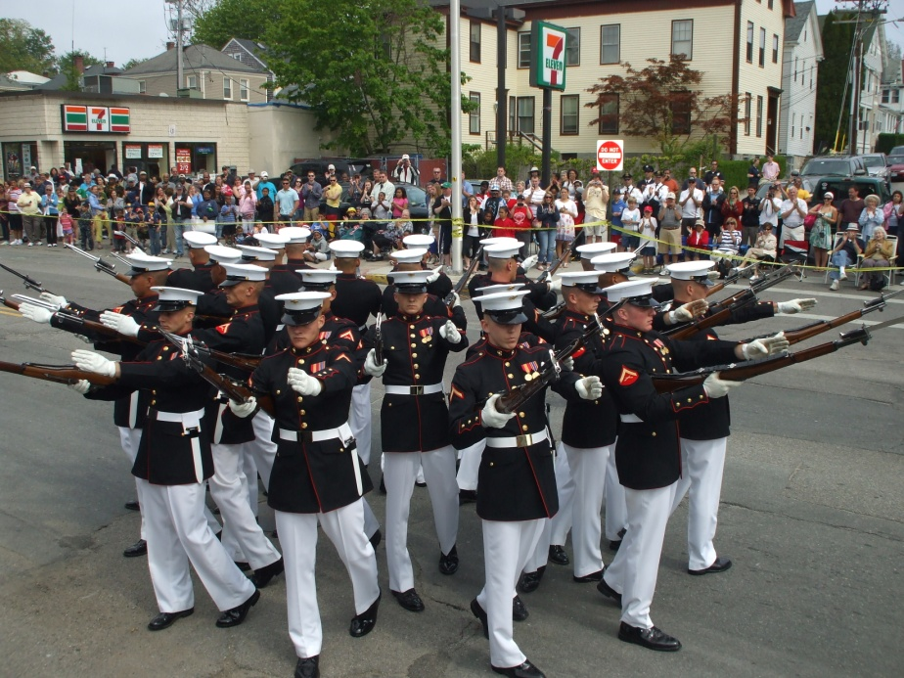
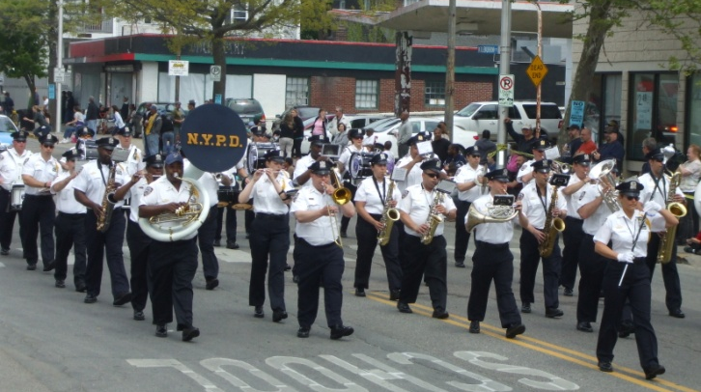
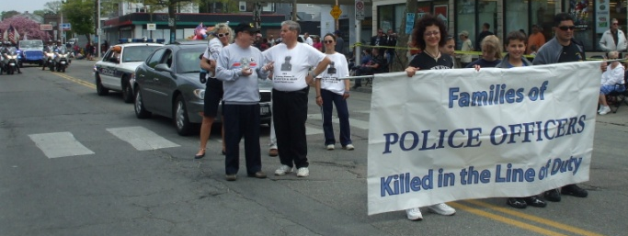
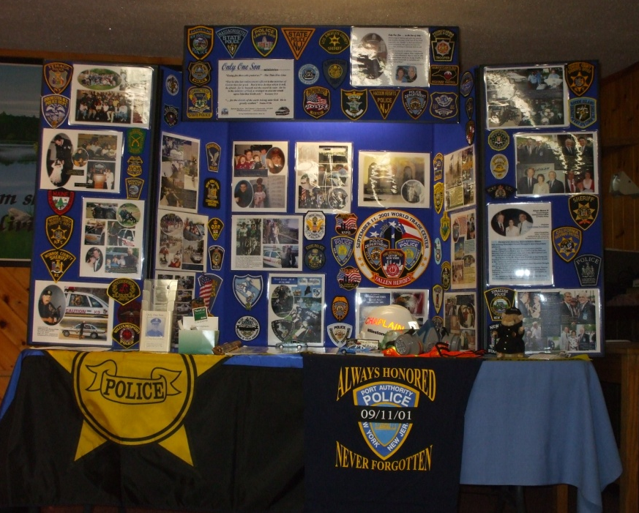
Upper left: Only One Son display; Top: the Annual Aquidneck Island National Police Parade, in Newport, RI, and families of officers slain in the line of duty; Above: the NYPD Marching Band at the Parade; Left: the U. S. Marine Corps Silent Drill Platoon, also at the Parade; Lower Left: Rhode Island State Police K-9s; Below: the State of New York Police Officers Memorial, in Albany, NY.

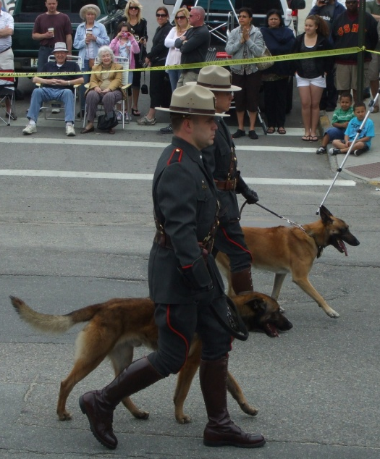
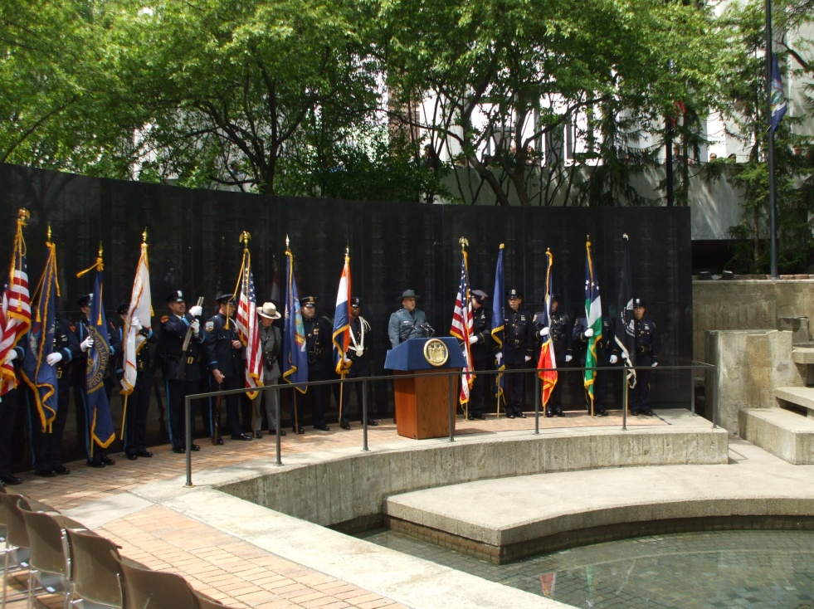
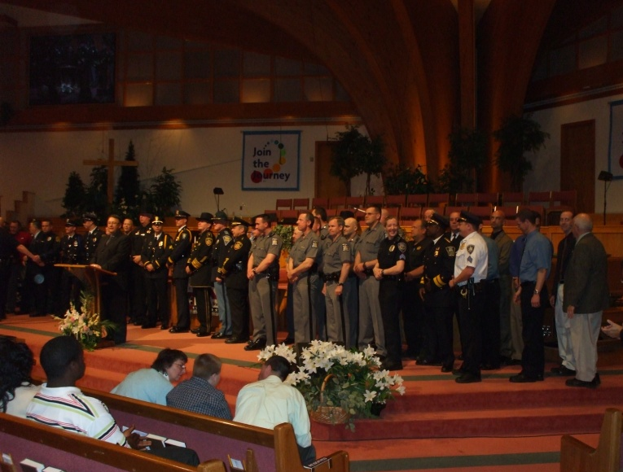
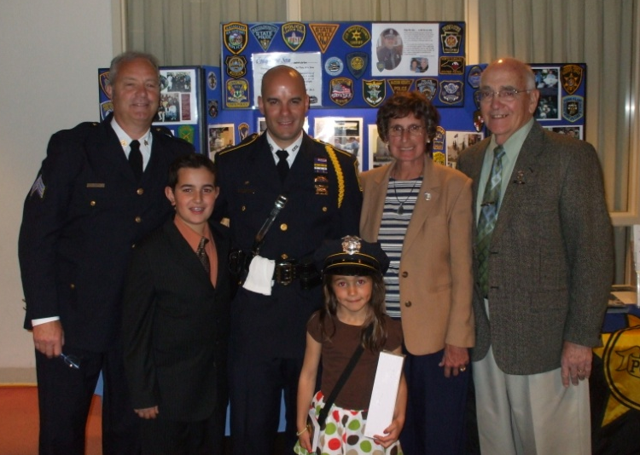
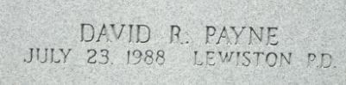
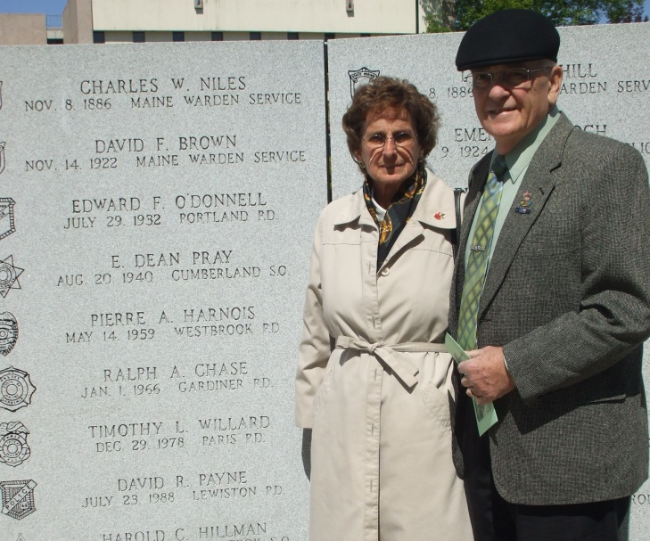
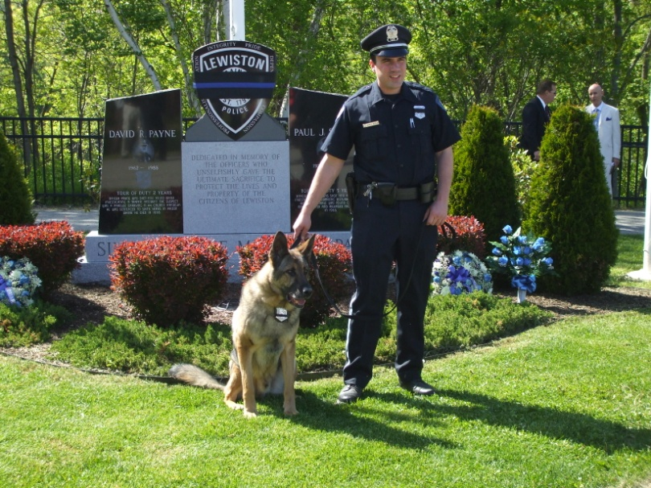
Upper Left: A Lewiston Police Officer and his K-9, at the Simard / Payne Memorial in Lewiston, Maine, following a service held on May 13th. Upper Right: the Paynes at the Maine State Law Enforcement Officers Memorial Wall in Augusta, Maine. Lower Left: Barb and Ray with Syracuse Police Officers, Sgt. Scott Bodah and Mark Techmanski, with Mark's two children, at the Annual Law Enforcement Appreciation Service at North Syracuse (NY) Baptist Church. Lower Right: Officers representing law enforcement departments and agencies cover the platform at North Syracuse Baptist Church, including the guest speaker, Major Tom Melville, of the Indiana State Police, while the Senior Pastor, Dr. George Miller III, leads in a prayer of dedication. The Millers are also the proud parents of two sons who are in law enforcement, one a NY State Trooper and one on the Binghamton Police Department.
We also spoke at a Police Appreciation hosted by Faith Baptist Church, in Cortland, NY. The pastor is also a police chaplain, Pastor Matt Smith, and a number of state and local officers attended. It is always encouraging to see pastors and churches reaching out to support and encourage law enforcement. The people of the church put on a tremendous meal for the officers and their families!

